Website Evaluation Form

I. General Information

- URL of site evaluated: http://atr555.neocities.org/islt_4360/Pilot_Site/Redmond_Pilot.HTML

- Author of site evaluated: Anthony Redmond

- Evaluator’s first name: Kayla Goth

II. Web site was evaluated on the following system

- Type of computer (Provide as much information as possible, i.e., Sony PC running Windows XP, Intel Pentium 4 , 2.80 GHz, 512 MB RAM):

- ASUS ProArt PA328Q Professional Monitor - 32" 4K UHD(3840 x 2160)
- Intel® Core™ i7-6700 CPU @ 3.4 GHz 3.41 GHz
- RAM: 32.0 GB
- 64-bit Operating System, x64-based processor

- Browser (e.g., Internet Explorer 8.0, Mozilla Firefox 2.0):
- Chrome in Windows 10 Pro

- Internet connection (e.g., cable modem, DSL, corporate or institutional):
- Corporate

III Design and Development

Instruction: For each of the questions below, rate your answer between one (strongly disagree) to five (strongly agree), and explain your rating for the clarification. Please take the time to explain your rationale in this form as it will help me write my Evaluation Report.

 | Strongly Disagree | Disagree | Neutral | Agree | Strongly Agree
DESIGN
- Document is subdivided into logical supporting pages or, if presented as a single page, it offers a table of contents with section links to avoid scrolling through entire document. | 1 | 2 | 3 | 4 | 5
Please explain your feedback

- The site is logically divided into tabs that would be easy to find and navigate if someone were interested in starting up a record label. The tabs are in an easy to spot location at the top of the page as well as a coordinating footer with those same links to where you don’t have to scroll all the way back to the top of the page if you wanted to immediately go to a different page.

- The site displays sound design principles, including uncluttered space, subdued backgrounds, and coordinated colors. | 1 | 2 | 3 | 4 | 5
Please explain your feedback

- The site has subdued backgrounds and coordinated colors which creates a unified site. With the subdued background colors, it’s also easier on the eye.

- However, when designing for the web, it would be best to use a sans-serif typeface. A serif font is when a font has a small line attached to the end of a stroke in a letter or symbol. Examples of this include Times New Roman or Cambria.

- I don’t like that the main text is justified in the boxes. When you make your window bigger and smaller, it creates awkward gaps.

- Navigation is intuitive, easy to understand, and provides flexibility in movement. | 1 | 2 | 3 | 4 | 5
Please explain your feedback

- The navigation is easy to understand because of the tabs on the top of the page as well as the hyperlinks to those same pages in the footer.

- Homepage is linked from all subsequent pages. | 1 | 2 | 3 | 4 | 5
Please explain your feedback
- The homepage is linked to all of the pages.

- Multimedia elements have a clear purpose. | 1 | 2 | 3 | 4 | 5
Please explain your feedback

- I’m not a fan of the image on the “Getting Paid” page. I’m a little confused as to what the image is actually saying. Perhaps it would be better to provide a stock image. You can find plenty of royalty-free stock images online. One good site is Pexels. This is a link to images about Money. https://www.pexels.com/search/money/
- I also have the same feeling about the image on the “Legal Info” page. Since the image you first see is money, my first thought would be to put that image on the “Getting Paid” page. I didn’t know if you wanted an out-of-focus image but it looks a bit rushed to me.
- I do like the images on the other pages that include the equipment. It’s a good way to connect to the viewers who would be interested in coming to the page.

- Multimedia elements load quickly or file size is indicated with user option to download. | 1 | 2 | 3 | 4 | 5
Please explain your feedback

- The multimedia elements loaded quickly, but there wasn’t an option to download. Maybe it is because my browser was fast?

- Images include alt, height, and width attributes and offer initial thumbnail graphic if file size is large. | 1 | 2 | 3 | 4 | 5
Please explain your feedback
- When I opened the images in a separate tab, it showed the dimensions of the image. It opened it to the full image and not a thumbnail version. Maybe the thumbnail one is what is included on the actual page.

- Text is easy to read and contrasts with background. | 1 | 2 | 3 | 4 | 5
Please explain your feedback

- The text DOES contrast with the background – but I think there are some hierarchy issues with the site. Meaning that it’s difficult to know immediately where you should start reading on the pages because the text is too close in size to each other.
- Also, the serif font choice is harder to read on a monitor. Serified fonts have a higher chance of displaying poorly, becoming blurry, or even pixelated.
- One thing you could to create some hierarchy in the site would be to keep your headings in the serif font and then the rest of the description text in a sans-serif font for some contrast. It creates a balance between the two.
- I would suggest making the text boxes not as wide. Web users tend to scan instead of directly read line-by-line and I think those long lines of text are a little intimidating to readers and it is a turn-off. The information included in them is insightful and great! It’s just that maybe decreasing the font size and making the boxes taller instead of wider would help the readability.
- EDIT: I think that since my monitor is 32” it made the text boxes very wide instead of shorter and squatter which is was I suggested to do. So, this is obviously not a fixed-width site? That (could) be problematic if a user is looking at your page on a larger monitor. Once I changed my window to where it wasn’t full-screen it was easier to read.

- Site content is widely accessible or appropriate adaptations or explanations have been made. | 1 | 2 | 3 | 4 | 5
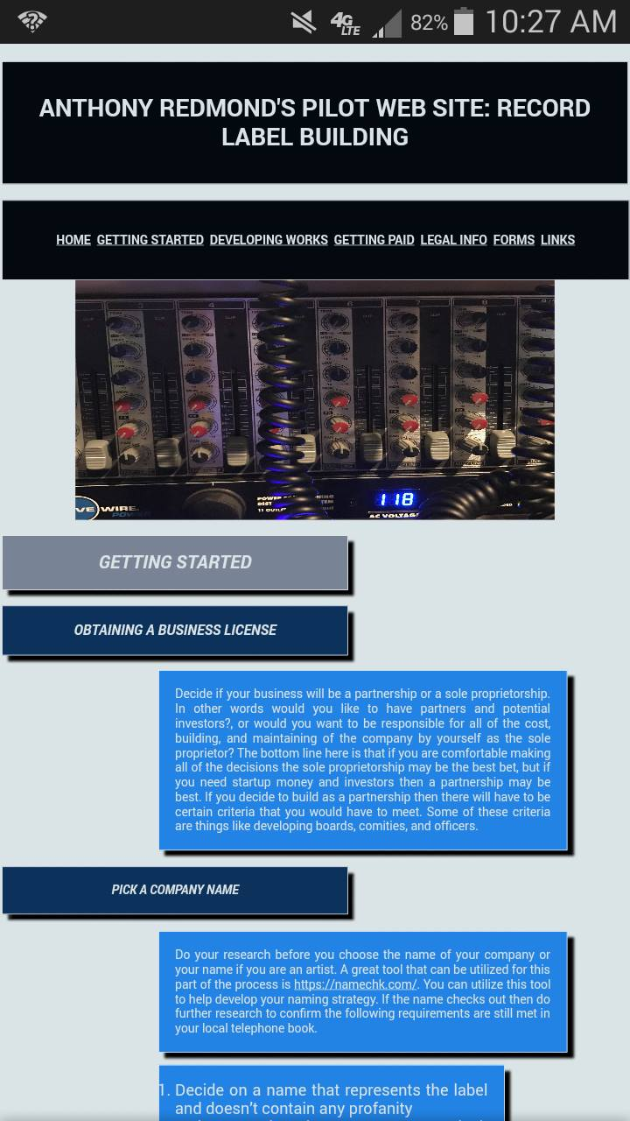
Please explain your feedback

- I tried viewing the site on different browsers. I even tried it on my phone and the font changed to a sans-serif font which ended up being MUCH easier to read – which I found VERY interesting.

 | Strongly Disagree | Disagree | Neutral | Agree | Strongly Agree
CONTENT
- Pages have clear and appropriate title in title bar. | 1 | 2 | 3 | 4 | 5
Please explain your feedback

- I can easily tell what page I am on and it isn’t too difficult to read.

- Links are appropriate, clearly labeled, and have a definite purpose. | 1 | 2 | 3 | 4 | 5
Please explain your feedback

- There aren’t any arbitrary links and they all work. You know what page you’re being directed toward.

- Links are up-to-date and functional. | 1 | 2 | 3 | 4 | 5
Please explain your feedback

- All of the links work and they take you to where you’re supposed to be.

- Useful content is embedded no further than two layers deep. | 1 | 2 | 3 | 4 | 5
Please explain your feedback

- Yes, all of the information is in 1 layer so it isn’t hidden or hard to find.

- Site contains in-depth content that encourages users to return. | 1 | 2 | 3 | 4 | 5
Please explain your feedback

- The site does have in-depth content. As far as encouraging the users to return, there isn’t really a call-to-action or anything. It’s more of an informational site so I guess if the user needed to return to look at the information, they could. I’m not sure how you can encourage a user to return to the informational site unless you decided to start doing a newsletter or something. But that’s beside the point.

- Information is accurate and current. | 1 | 2 | 3 | 4 | 5
Please explain your feedback

- I don’t know much about starting a record company, but the information looks accurate to me. It shows that the webpage was last edited on 10/30/16 so it is current.

- Site stimulates thinking and reflection or serves a useful purpose for an identified audience. | 1 | 2 | 3 | 4 | 5
Please explain your feedback

- I think this site would be very informative for someone who would be interested in starting a record label. It has a very specific purpose. It caused me to think about all of the aspects it takes to start a record label.

 | Strongly Disagree | Disagree | Neutral | Agree | Strongly Agree
CREDIBILITY
- Credibility is established by including information regarding author, affiliations, and credentials. | 1 | 2 | 3 | 4 | 5
Please explain your feedback

- Based on the information given, Anthony has shown that he is knowledgeable about the industry. However, maybe on the homepage it would be useful to have a blurb about him and why he would be a trustworthy source. Or maybe even a separate tab?

- Contact person with e-mail address is included. | 1 | 2 | 3 | 4 | 5
Please explain your feedback

- It says to contact Anthony & also provides his email address.

- Site is bias-free or explicitly states point of view. | 1 | 2 | 3 | 4 | 5
Please explain your feedback

- The site isn’t biased; it is informational and it isn’t pushing his views on to the viewer.

- Material is original or includes appropriate citations with no copyright infringement. | 1 | 2 | 3 | 4 | 5
Please explain your feedback

- I’m not sure if this information is just what he’s learned from being in the industry or if he used additional resources to help develop the page. There is a links page that provides additional resources and in-depth information so he would be covered from copyrighting from those sites.

- Correct punctuation, spelling, and grammar indicate care and attention to detail. | 1 | 2 | 3 | 4 | 5
Please explain your feedback

- I didn’t notice any distracting grammar/spelling issues. But here are some minor issues:
- On the Homepage, it says “If your answered “NO”…” it should be “If you answered “NO”…”
- Capitalize “Secretary of State” on the “Getting Started/Pick a Company Name” part.

- Site indicates date(s) that material was created or updated. | 1 | 2 | 3 | 4 | 5
Please explain your feedback

- In the footer, is says that the site was last updated on 10/30/16

